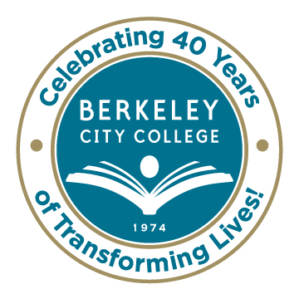
Roundtable
For Planning and Budgeting

AGENDA
Monday, September 29, 2014

12:15 p.m. - 1:30 p.m.

Room: 451A-B

Chair: Dr. Debbie Budd
- Institutional Planning and Strategic Goals
  - Annual Goals, activities and outcomes
  - Validating 2014-15 Goals
  - Audacious Goals Vision 2024

- Equity Plan - Eliminating the Achievement Gap

- Budget
  - SSSP funding $800,000 to the college (SSSP funds/Equity funds handout )
  - Equity funding $1,372,828 to the district
  - BSI funding $90,000 to the college
  - How do we leverage these different funding sources to do the work to come?
  - Are there other funds that we need to include in this conversation?
  - What other needs have been identified through our planning process that still need funding ?

- Shared Governance Manual

- Accreditation Update

- Other

***********
Our Mission: Berkeley City College’s mission is to promote student success, to provide our diverse community with educational opportunities, and to transform lives.

Our Vision: Berkeley City College is a premier, diverse, student-centered learning community, dedicated to academic excellence, collaboration, innovation and transformation.

