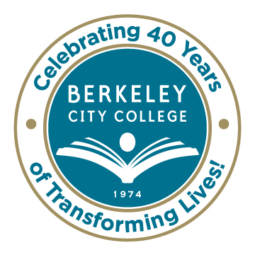
College Roundtable for Planning and Budgeting

AGENDA
Monday, October 27, 2014

12:15 p.m. - 1:30 p.m.

Room: 451A-B

Chair: Dr. Debbie Budd

- Agenda Review

- Review and Approval of 10/13 Minutes

- Review of Vision 2024 Goals and Vison 2024 Vision indicators

- Planning Timelines – Annual Program Updates

- Accreditation
Link to accreditation documents: http://eberkeley.org/resources/course/view.php?id=100

- Review of entire draft document
- Introduction
- Standards
- Actionable Improvement Plans

***********

Our Mission: Berkeley City College’s mission is to promote student success, to provide our diverse community with educational opportunities, and to transform lives.

Our Vision: Berkeley City College is a premier, diverse, student-centered learning community, dedicated to academic excellence, collaboration, innovation and transformation.

