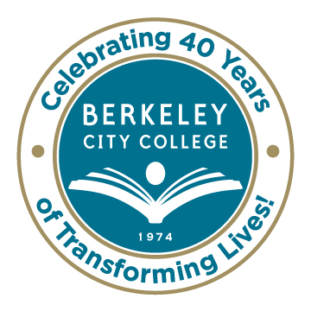
College Roundtable for Planning and Budgeting

AGENDA
Monday, January 26, 2015

12:15 p.m. - 1:30 p.m.

Room: 451A-B

Chair: Dr. Debbie Budd
Discussion Topic Facilitators:
Dr. Debbie Budd, President
Dr. May Chen, Vice President, Student Services
Ms. Tram Vo-Kumamoto, Vice President, Instruction
Ms. Brenda Johnson, Dean, Student Support Services
Dr. Carlos Cortez, Dean, Academic Pathways & Student Success
Ms. Shirley Slaughter, Director, Business & Administrative Services
Ms. Jenny Lowood, Faculty

- Review of Agenda and December 8th Roundtable Minutes – Debbie

- Institutional Self-Evaluation Updates – May/Jenny

- Educational Master Plan Update – Tram
  - Timelines
  - Table of Contents

- Annual Program Update/Faculty Prioritization Rubric – Tram

- Budget Review – Status To Date (Burn Rate) – Shirley

- Equity Plan Highlights and Week’s Activities – Carlos/Brenda

- Other

***********
Our Mission: Berkeley City College’s mission is to promote student success, to provide our diverse community with educational opportunities, and to transform lives.

Our Vision: Berkeley City College is a premier, diverse, student-centered learning community, dedicated to academic excellence, collaboration, innovation and transformation.

