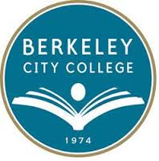
Vision 2024: Berkeley City College at 50
October 3, 2014
9-12pm
Education Master Plan Meeting #2 – Program of Study

9:00-9:30 | Welcome and Introductions
9:30-10:00 | Education Master Plan Proposal – presentation
10:00-11:00 | Discussion re: proposal – Concerns/ Needs
11:00-12:00 | Activity – Small group discussion regarding current programs and opportunities for new programs

