BCC Special Projects and CTE Update
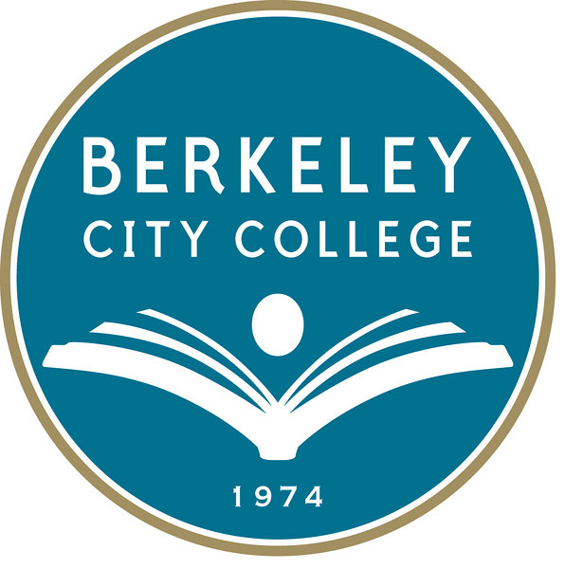
District CTE: BCC CTE Faculty & Students Needed!
Peralta Community College District (PCCD) CTE Committee has officially returned! At the last District Education meeting, the CTE Committee’s purpose and structure was supported. Continued thanks to Dr. Des Rochers, Theresa Rumjhan, Catalina Herrera, and Katherine Bergman for attending the planning meetings, actively participating, and advocating!

Based on the District Ed Committee vote, the CTE Committee will include a District rep, one College President, one College Administrative representative from each sister college, two CTE Faculty from each campus, and four students. Faculty and Students are to be nominated by their respective Senates. BCC CTE Faculty & Student participation is MOST necessary- CTE Faculty and Student please reach out you Senate!

BCC Eligible for Deputy Sector Navigator Funding
BCC is honored to be one of the local community colleges eligible for California Community Colleges Chancellor’s Office Deputy Sector Navigator funding to build regional industry partnerships in the Information and Communications Technology (ICT)/Digital Media sector. Released in March 2014 and clarified by the CCCCO in mid March after some confusion amongst the regional colleges, this RFA is due in mid-April!

BCC believes that our Multimedia Arts faculties’ ardent work to build industry advisory councils is worth developing and sharing regionally. After discussion with BCC Multimedia Arts Department Chair and Faculty, BCC part-time faculty member, high school teacher, and 2D/3D animator Mary Clarke-Miller has agreed to be put forward in the application for this position.

Please find information on the DSNs here: http://extranet.cccco.edu/Divisions/WorkforceandEconDev/WEDDRFAs/RFADSNICTDMEastBay.aspx Questions are most welcome! Please contact Katherine Bergman (mbergman@peralta.edu).

PCCD Submits $15M CPT Application for Region
On 28 March 2014, PCCD submitted a regional application for $15M in Career Pathways Trust funding. For more details of the East Bay 1-80 Corridor Career Pathways Consortium and PCCD-led planning process: http://peraltaccd.granicus.com/MetaViewer.php?view_id=&clip_id=540&meta_id=62508
BCC was deeply proud of the active participation of our CTE Faculty and Staff at the last two months’ CTE Sector events, including: Life Sciences & Engineering (Drs. Des Rochers and Omar for Biotechnology and Engineering), Public Service & Justice (Stephanie Green for PHS, Juana Alicia for Public Art, and Katherine Bergman for Educational Assistant and Spanish Medical Interpreter), and ICT/Digital Media, which was hosted by BCC, (Sabrina Nelson, Rachel Mercy Simpson, Mary Clarke-Miller, Justin Hoffman, and Lee Marrs (via Skype!!)).

BCC CTE Industry Advisory Boards Continue and Grow!
BCC is excited and grateful for the work of BCC Faculty to develop and maintain their BCC CTE Industry Advisory Boards to gather critical data on CTE industry sectors, employment demand, and skills to support our students in succeeding.

In fall 2013, the Educational Assist/Aide (General, ESL, and STEM) met for the first time to gather data to assist in the creation of their program. This spring 2014, Multimedia Arts faculty, led by Sabrina Nelson has continued this work. Industry, including former students of our CTE instructors, and now leaders at Pixar, Industrial Light and Magic, MTV, EA, and other Animation and Game organizations gathered to support our Multimedia Arts Animation Strand with data needed to develop cutting-edge 3D coursework.

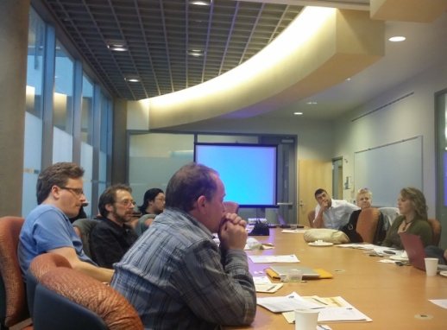
BCC Multimedia Arts Animation Strand Industry Advisory Council

BCC ESL Advisory, International Student Task Force and Increased International Student Resources at BCC!
The work of the ESL Faculty on the BCC ESL Advisory continues, meeting a second time in April, this excellent group of Students, Faculty, Staff, and Community members, including BAS, UCB, City of Berkeley, and other CBOs/FBOs provides guidance to the ESL Faculty on critical ESL student as well community and industry issues needs. The next ESL Advisory Board with be 1 May 2014 from 4-6PM. Please feel free to RSVP to Laurie Brion (lbrion@peralta.edu).

A diverse group of Students, Faculty, Staff, and Administrators have gathered together this spring to form an International Student Task Force. Interested in joining the International Student Task Force? The next International Student Task Force is this Thursday, 10 April 2014 from 3:30 to 4:30 in the TLC. Please join us! Also feel free to contact Katherine Bergman, mbergman@peralta.edu with any questions.

Both groups are deeply excited about the new International Student resources at BCC, including: new Counseling Faculty Susan Troung (stroung@peralta.edu) with significant Learning Community experience at Laney College and training in International Student issues, and weekly International Student Services by District International Student Specialist Thomas Torres-Gil, DSO (ttorresgil@peralta.edu) each Thursday in Room 511 (to the right out of the 5th floor elevator).

Please feel free to refer International Students to this dynamic team; they are both especially devoted assisting these students to succeed at BCC!

SB 1070: $1.8M in Regional CTE Systems Development
As noted in January, SB 1070 grant monies ($1.8M over 3 years for the Northeast Bay Region) was awarded to fund capacity building and infrastructure to support clear and sustainable CTE pathways from HS to CC. The funding provides for a regional director to facilitate a year of planning between the HS and CC, and then two years of CTE capacity, systems, and policy work around data, alignment, industry partnerships, CTE educator PD, and outreach for all of our CTE pathways.

BCC joined with consortium members at the SB 1070 Kickoff meeting at Diablo Valley College on Friday, 21 February 2014. BCC was delighted to see Laney, COA, and District colleagues, and to be selected to join the Executive Planning team. Questions, interest? Please contact Katherine Bergman (mbergman@peralta.edu).

Adult Funding: $330K for East Bay Adult Ed Planning
In March, a multi-district consortium of adult schools and community colleges finally applied for non-competitive AB 86 Adult Education planning resources. Peralta Community College District, including BCC, is delighted to serve on this Adult Ed. Regional Consortium with six local adult schools!

Piedmont Adult School will serve as fiscal agent for AB 86 during this planning period with the purpose of developing regional plans for adult education. The Adult Education Regional Consortium will have a 10 member representative group with 5 members from the Adult Schools and 5 from PCCD and the sister colleges. Adult school community college teams will facilitate internal and partner discussions around HS diploma/GED, ESL, educating adult students with disabilities, CTE, and apprenticeships. If interested, please do not hesitate to contact Katherine Bergman (mbergman@peralta.edu).

Linked Learning Initiative: LA AME Industry Conference
BCC was honored to participate with partner Linked Learning Skyline High School at the February 5th Linked Learning Initiative Arts, Media, and Entertainment Sector Industry Conference in Los Angeles. Attendance was fully funded by the California Community College Linked Learning Initiative.

In addition to presenting with Skyline Computer and Technology Academy Director Mary Frey and Assistant Principal Anya Gurholt on the development of the BCC-OUSD partnership, BCC enjoyed the opportunity to hear from state and local producers, directors, and editors within the Arts, Media, and Entertainment sector. These employers stressed their desire for a relationship with the California Community Colleges to increase diversity within the sectors, and to ensure increased technical and entrepreneurial skills for students joining them.

For more information about the summit and CCCLLI, http://www.careerladdersproject.org/initiatives-programs/california-community-college-linked-learning-initiative-ccclli-2/ame2014/

District Data: PCCD Data Training at BCC & New Hires!
The Office of Special Projects is delighted that the District has begun to respond with new data resources for the sister colleges.

In addition to providing Faculty and Staff training on the BI tool at BCC, PCCD has secured two new researchers within Education Services. BCC excitedly looks forward to the new members of the PCCD IR team setting up query for requested Basic Skills, Learning Communities, and CTE queries so this information gathering is systematically made and may be used every year to support data-driven decision making!

