BCC Special Projects and CTE Update
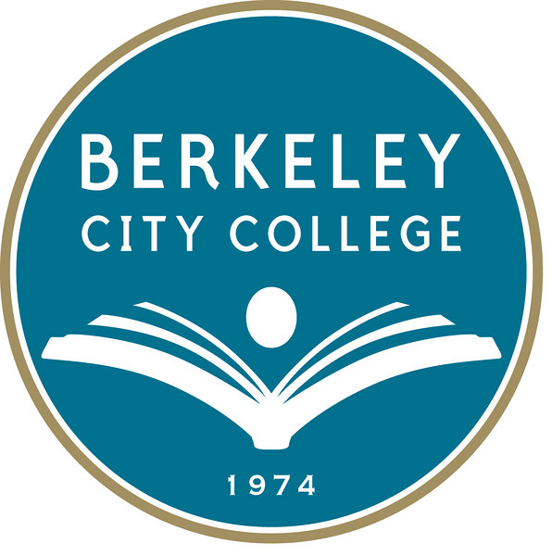
District CTE Committee; Development Lead
Peralta Community College District (PCCD) CTE Committee has returned! After the advocacy of CTE Faculty and Administrator, Chancellor Ortiz fully supported PCCD CTE Committee reinstitution under the District Ed Committee. Currently, the CTE Committee is collaboratively completing Shared Governance purpose and structure. Thanks to Dr. Des Rochers, Theresa Rumjhan, Catalina Herrera, and Katherine Bergman for attending Friday meetings and actively participating.

PCCD has tapped East Bay Economic Development Association’s former Executive Director Karen Engel, PhD to lead Development for the District. Dr. Engel has worked thoughtfully and rapidly to bring together the sister colleges and prepare proposals for major CTE grants, including Prop 39 and AB 86.

BHS-BCC Instructors Connect for Student Success
BCC instructors and BHS instructors met recently to review existing alignment/articulation, and plan the next steps for aligning programs, BHS outreach, and articulating courses. Programs participating included:

- BHS and BCC English Department
- BHS and BCC Math Department
- BHS and BCC Science, specifically Biotechnology
- BHS and BCC Learning Communities, specifically Public and Human Services and Academy of Medicine and Public Service (AMPS)
With respect to BHS-BCC math and English, discussion included ensuring BHS students understand and can easily traverse BCC placement testing, understand which BHS courses align to BCC courses, and know of the opportunity to take BCC courses while at BHS.
With respect to CTE programs, after reviewing existing articulation agreements between the programs, Biotechnology and Public and Human Services instructors explored alignment of their programs, BHS-BCC outreach, and articulation of courses, including Medical Instrumentation.

BCC is deeply excited by our work with BHS, and the calendared next steps, including the meeting of BCC and BHS Multimedia Art programs set for this week.
In addition to participating BCC faculty, BCC cannot thank more strongly BHS VP Kristin Glenchur who has been instrumental in ensuring these faculty connections and mapping of all BCC programs to BHS academies and programs in the next BHS catalog.

In addition to ensuring BCC and BUSD has already begun the work of awarded SB 1070 ($1.8M for HS-CC CTE pathways systems work) and AB 86 ($330K awarded for adult school work, including BAS), we are delighted BHS students, parents, and teachers will have the opportunity to understand the clear and affordable pathways, to college and career, available to them right here in Downtown Berkeley!

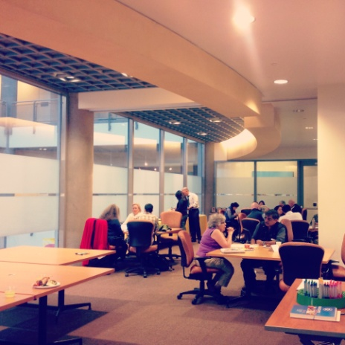
BHS-BCC Instructor Meet Up

BAS-BCC Adult Education Collaboration
Also of note is the continued collaboration with BCC and Berkeley Adult School (BAS), especially surrounding CTE and ESL pathways. In addition to the BCC ESL Faculty, we give special thanks to Burr Guthrie for his tireless energy and support of this work.

BCC was honored to bring Berkeley community partners together last week for the BCC ESL Advisory Panel, including BAS, City of Berkeley, and UC Berkeley.
Panel feedback resulted in developing UC Berkeley outreach materials outlining the benefits of both the BAS and BCC ESL programs to ensure students find the best program for their circumstances. BCC was also grateful for City of Berkeley’s commitment to improve employee skills, including sending employees to BCC.

Also emerging was interest in an International Student Task Force. Interested? Please contact Katherine Bergman, mbergma@peralta.edu .

SB 1070: $1.8M in Regional CTE Systems Development
SB 1070 grant monies ($1.8M over 3 years for the Northeast Bay Region) have been awarded to fund capacity building and infrastructure to support clear and sustainable CTE pathways from HS to CC.

The funding provides for a regional director to facilitate a year of planning between the HS and CC, and then two years of CTE capacity, systems, and policy work around data, alignment, industry partnerships, CTE educator PD, and outreach for all of our CTE pathways.

Adult Funding: $330K for East Bay Adult Ed Planning
Recently, a multi-district consortium of adult schools and community colleges successfully applied for AB 86 planning resources. Peralta Community College District, including BCC, is delighted to serve on this Adult Ed. Regional Consortium with six local adult schools!
Piedmont Adult School will serve as fiscal agent for AB 86 during this planning period with the purpose of developing regional plans for adult education, including:
- Elementary/secondary basic skills, including diploma or GED coursework;
- Citizenship and ESL classes and courses for eligible immigrants and basic skills workforce preparation;
- Education programs for adults with disabilities;
- Short-term high-employment CTE programs; and
- Programs for apprentices.
Currently, the Adult Education Regional Consortium will have a 10 member representative group with five members from the Adult Schools and five from PCCD and the sister colleges. Co-chairs are OUSD Adult School’s Christian Nelson and PCCD’s Karen Engel. Adult school community college teams will facilitate internal and partner discussions around HS diploma/GED, ESL, educating adult students with disabilities, CTE (Katherine Bergman), and apprenticeships.

AB 86 Funding: Clear CTE Pathways our Community
The AB86 funding is explained as the implementation funding for the systems and policy work (Data, Outreach and Marking, Professional Development, Intersegmental Partnerships, and Alignment priorities) to be conducted under the SB 1070 grant.

Based on feedback from Connect ED, who is communicating with the Chancellor’s office at the state, this funding is best applied for together as a larger consortium, and is likely, as a state budget line, to be renewed after the 4 year period of this grant.

AB 86 Funding Priorities: BCC is ready
The AB 86 funding priorities, VERY thankfully, tie closely to the exceptional programmatic work of BCC:
- Specialists in work-based learning to convene, connect, measure or broker efforts to establish/enhance a locally defined career pathways program that connects school districts, COEs, charter schools, and community colleges with business entities.
- Establish regional collaborative relationships and partnerships with business entities, community organizations, and local institutions of postsecondary education.
- Develop standards based academics with career-relevant, sequenced curriculum following industry themed pathways aligned to high need, high growth, or emerging regional economic sectors.
- Articulate pathways to postsecondary education.
Linked Learning Initiative: LA AME Industry Conference
BCC has been invited to present with Skyline High School at the February 5th Linked Learning Initiative Arts, Media, and Entertainment Sector Industry Conference on the BCC-OUSD partnership.

Title III Annual Performance Report; District Data!
In January, the Title III Annual Performance report was timely submitted to Department of Education to report on the work of the Assessment Committee, TLC as well as the English, ESL, PERSIST, and Global Studies Programs.

In completing this work, a request for annual updates on BCC Basic Skills student success has been made by the Title III Director and President Budd to PCCD IR.
