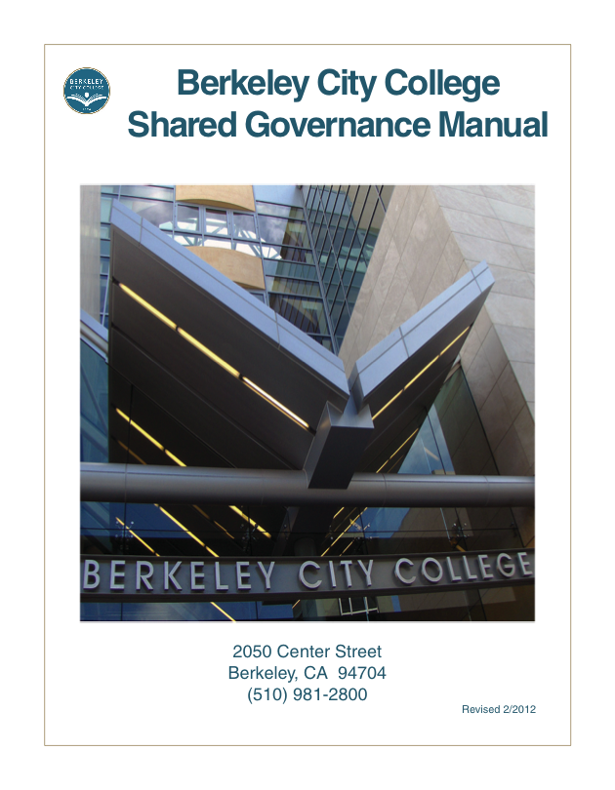

Table of Contents

Page

Mission, Vision, Values, and Goals 1

Overview of Shared Governance 3

Shared Governance Flow Chart 8

College Governance
College Roundtable for Planning and Budget 10
Leadership Council 11

Senates

Classified Senate 13
Faculty Senate 14
Associated Students of Berkeley City College 16

Standing Committees

Assessment Committee 18
Curriculum Committee 19
Department Chairs’ Council 20

Ad Hoc Committees

Bookstore Committee 22
Commencement Committee 23
Community Relations and Outreach Committee 24
Scholarship Committee 25
Safety Committee 26
Teaching Learning Center Advisory Committee 27
Technology Committee 28

The Shared Governance Manual, describing BCC committees with the annual list of active committees and the individuals who are members, will be maintained in the Office of the President.

Depiction of Planning and Budget Integration
and
Decision Making
Board Decision Making
Program Review

Recommendation to the Chancellor
Planning and Budget Integration
Planning & Budgeting Council
Education Committee
Technology Committee
Facilities Committee
.
Recommendation to the President

BCC Roundtable
Academic Senate
Classified Senate
Summarizing data
Conduct assessments
Dialogue
Enhancement
Plan methods
of assessment
SLO Defined
(Redefined)
BCC Councils, Committees, Division Meetings
BCC Leadership

College Roundtable for Planning and Budget

Chair: College President
Membership:
Vice President of Instruction,
Vice President of Student Services
Deans
Business and Administrative Services Manager
Director of Special Projects
Executive Assistant to the President
Faculty Senate President and 3 faculty appointees
Classified Senate President and 3 classified staff appointments
ASBCC President or designee(s)

Length of Term: Indeterminate
How Selected: Appointed by respective bodies

Purpose

The charge of the committee is to advise the administration on planning issues. Initially the charges will address the college strategic missions in the following ways:

- Give college-wide input on planning and budget
- Link planning documents to district missions and goals, strategic plans, and accreditation standards to inform budget decisions
- Review programs planned and in place in order to make recommendations as to what resources are needed for those programs. Develop a framework or model for this.
- Prioritize resource allocation based on recommendations that are informed by defined criteria and outcomes.
- Inform the college about strategic goals and the activities of this group.

Recommends to: College President
Frequency of Meetings: Twice per month

Leadership Council
Chair: College President
Membership:
Vice President of Instruction
Vice President of Student Services
Deans
Business and Administrative Services Manager
Public Information Officer
Faculty Senate President (or designee)
Classified Senate President (or designee)
Associated Student Body President (or designee)
Department Chairs Council Representative

The Executive Assistant to the President will send meeting notices and record action items from the meeting.

Length of Term: As long as position held
How Selected: By virtue of the position held

Purpose

The Leadership Council will:
- create, review, and revise committees;
- receive reports at least annually from all standing and ad hoc committees of the college;
- receive reports from district governance committee representatives and provide advice to the representatives in response;
- receive and review college procedural recommendations;
- adopt, review and revise college procedures;
- assess college needs to ensure systematic development of procedures;
- obtain constituent opinions;
- provide a venue for college-wide initiatives and provide a means of communication with the college community;
- discuss proposed changes in broad-based college processes before they are acted on or implemented by the College President;
- examine and discuss issues of college-wide importance in depth with the goal of ensuring that the institution as a whole is true to its mission, clear in its identity, and effective in serving students;
- consider issues brought forth from other bodies or from college constituencies and either (1) make a recommendation to the president or (2) refer the matter to another, more appropriate, body such as the College Roundtable for Planning and Budget;
- review, approve, and/or improve recommendations made by other bodies, as appropriate
- assess the effectiveness of the Leadership Council.

Recommends to: College President
Frequency of Meetings: Twice per month

Technology Committee
Membership

Reporting directly to the Roundtable, the Technology Committee serves the purpose of the shared governance decision-making process at BCC. The committee is composed of representatives from all constituency groups.

2012- Membership

Co-chairs:

May Chen, Ph.D. Vice President of Student Services
Leonard Chung Instructor, Computer Information Sciences/Business

Members:

Fabian Banga, Ph.D. Department Chair, Modern Language; Distance Education Coordinator
Linda Berry, Ed.D. Vice President of Instruction
Joshua Boatright Department Chair, Librarian
Ramona Butler Secretary, Student Services
Shirley Fogarino Public Relations Officer; Instructor, Business
Bryan Gibbs Multimedia Services
Vincent Koo Campus Network Coordinator
Roberto Gonzalez Alternate Media Specialist
Brenda Johnson Dean, Student Support Services
Lee Marrs Department Chair and Instructor, Multimedia Arts
Loretta Newsom Admissions and Records Specialist
Siraj Omar, Ph.D. Department co-chair, Science; Instructor, Chemistry
John Pang Supervisor, Business Office
Student representative

