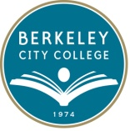
Loan Workshop Request Form

Student Name:
Student ID:
Address:
Email Address:
Phone Number:
Academic Term: | - Fall 2017  - Spring 2018

All workshop will be from 12:15 pm to 1:00 pm in Room 126:

- Wednesday, August 30, 2017
- Thursday, September 14, 2017
- Monday, September 25, 2017
- Tuesday, October 10, 2017
- Wednesday, October 25, 2017
- Friday, December 01, 2017

**Please note: We will not let students attend the workshop 15 minutes after it begins. Please plan accordingly. Dates and time are subjected to change. We will notify you for further updates.

Signature: _____________________________ Date:_____________

