English as a Second Language (ESL)

Public Programs in Berkeley
Berkeley Adult School  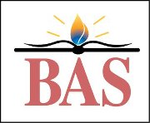  1701 San Pablo Ave  Berkeley, CA 94702  bas.berkeley.net/esl.html  (510) 644-6130 | Berkeley City College  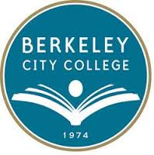  2050 Center St  Berkeley, CA 94704  www.berkeleycitycollege.edu/wp/esl/  (510) 981-2858
Beginning – high intermediate level ESL courses | High intermediate – advanced (college level) ESL courses
$45 per class per semester | - California residents: $46 per unit (1 hour/week for 16 weeks)  - Non-residents: $213 per unit  - plus fees (per semester):  - Campus Center Use $2  - AC Transit Easy Pass, $36  - Health Fee $18 fall and spring, $15 summer  Full-time student = 12 units  Financial Aid available for qualified resident students
Free parking lot for students | Pay parking garages and street parking
Open enrollment (start anytime, registration open from mid- August to end of April each year). | Classes begin in Fall (September-December), Spring (February-May), and Summer (June-July). No open enrollment.
Online/Distance Learning alternative/supplement available | Some courses hybrid (partially online)
Non-credit classes | College credit classes  Certificates of Proficiency in High Intermediate and Advanced ESL
Does not issue Form I-20 for F-1 Visa (international) students | Issues form 1-20 for F-1 visa (international) students/  full-time study (12+ units/semester)
 | International Student Services and International Student Club
BOTH
- Morning, afternoon and evening classes  - Strong ESL community and campus life activities  - Many other types of classes, including CTE (Career Technical Education)  - Close to public transportation  - Access to computer labs |  | - International/immigrant/undocumented students of all ages  - Working students, high school students, parents, transfer students, graduate students, visiting scholars and family members  - Preparation for career advancement, college/university, and/or CTE

