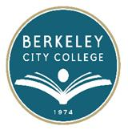
EDUCATION COMMITTEE FOR QUALITY PROGRAMS AND SERVICES

AGENDA
Thursday, September 10, 2015

12:20 pm – 1:20 pm

Room: 311

Agenda Item
- Call to Order
- Minutes: 4.23.15 &5.14.15
- Charge & goals for 2015-2016
- Equity Plan- Timeline and workgroups, Preliminary target areas
- Joint Projects-Suggestions from counselors
- Majors showcase week of October 19- college hour, counselor liaisons and department
- Live week- Counselors- English/ ESL classes
- Multiple Measures Implementation
- Other

