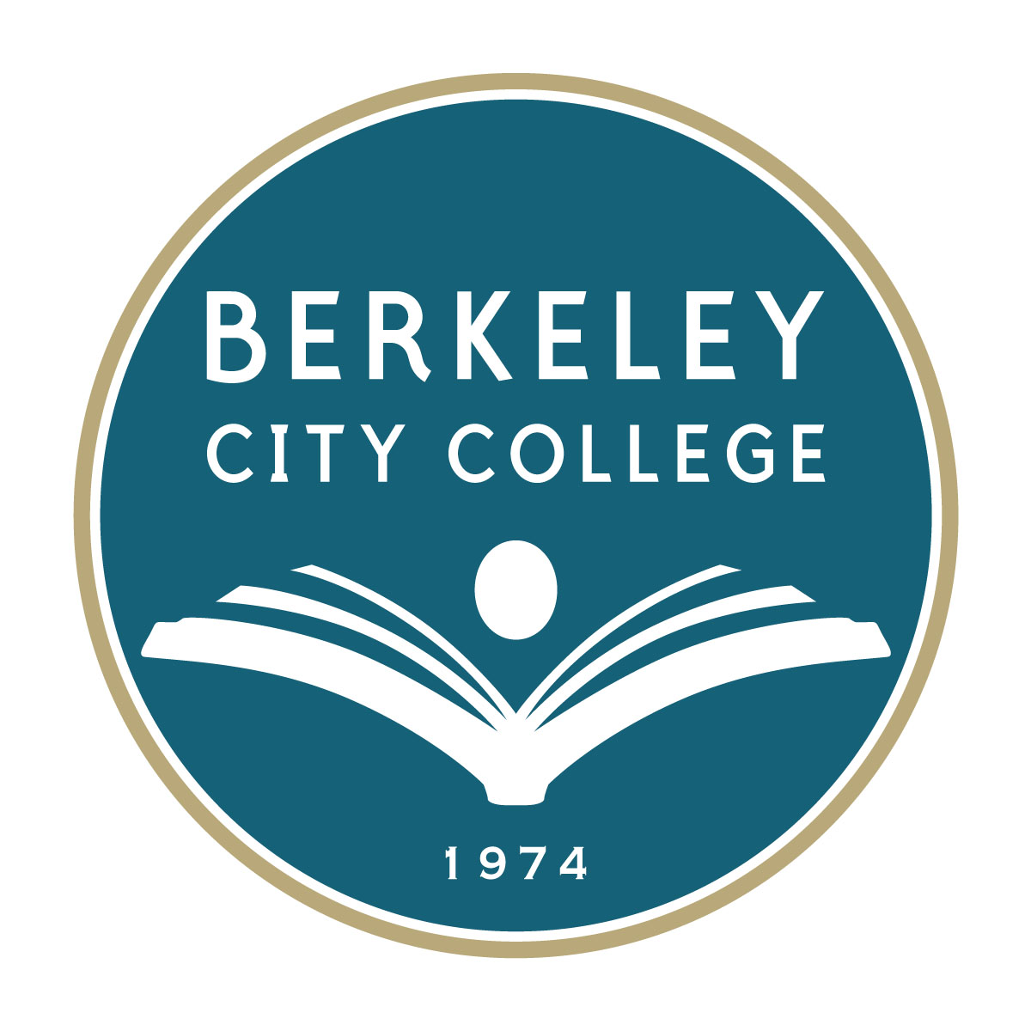

Berkeley City College

Equity Report and Plan

2008

Angela Gallegos-Castillo, Ph.D.

Federico Castillo, Ph.D.

Marilyn Sargent, Ph.D.

Mario Rivas, Ph.D.

Equity Committee, Berkeley City College

Berkeley Community College Equity Committee

Dr. Mario Rivas, Vice-President of Student Services

Dr. Gloria Vogt, Dean of Instruction

Brenda Johnson, Dean of Student Support Services

Dr. Marilyn Sargent, BCC Research & Planning

Noel Cantu, Associated Students of Berkeley City College Representative

Dr. Gabriela Pisano, Faculty

Luna Finlayson, Academic Senate Representative

Ayele Lemma, Classified Senate Representative

Laura Bollentino, College Articulation Officer

Berkeley City College
Equity Report and Plan
Executive Summary

Berkeley City College (BCC) is a vibrant teaching institution serving a diverse community, representing students from a wide variety of ethnic groups, socioeconomic class, gender, physical capability as well as other differences. This Equity Report and Plan presents a review and a plan to support the progress of all ethnic groups as mandated, including a special focus on underrepresented students. Five areas of college functioning are highlighted for comparison and analysis, as mandated: Access to the college programs and services, as well as Course Completion, Basic Skill Completion, Degree and Certificate Completion, and Transfer of Student to 4-year colleges and Universities. Based on the Equity Report, the BCC Equity Committee formulated an Equity Plan to support the success of all student populations at BCC. This summary is intentionally brief; please consult the appropriate part of the report that follows for detail and elaboration.

Equity Report
With respect to Access, Berkeley City College draws a diversity of students from local communities. African-American and Latino students are well represented in the college relative to their percentage of the general population within surrounding communities. Since community colleges are the primary entrance point to higher education for underrepresented groups, BCC aims to exceed and excel in programs and services to these groups.

Several areas show gaps in the success of different ethnic groups. With respect to Course Completion in fall 2006, the ethnic groups with completion rates above the college average (65.3%) are Asian (74.5%), White (71.4%), and Hispanic/Latino (65.8%), while Native American (50%) and African-American (51.6%) groups show lagging course completion rates.

Basic Skills Completion Rates present data for reflection and action. African-Americans complete basic skills courses at rates 10% or more below the college average in fall 2006. That is, African-American rates stand at 31% for both English and math, as compared to college rates of 41% in English and 45% in math. African-Americans make up roughly half of the students enrolled in basic skills. Males trail females in completing basic skills English by 10% in fall 2006; that is, the female completion rate for English is 45% compared with the male rate at 35%. Males lag females by 4% in the basic skills math completion rate; females achieve rates of 46.7%, while males show rates of 43.4%.

Degree and Certificate Completion shows that both African-American and Hispanic/Latino groups earn awards at rates higher than their proportion of the
enrolled students. African-Americans earn 30% of awards with 25% of the
student enrollment, while Hispanic/Latinos earn 17% of awards with 13% of enrollment.

Transfers to UC and CSU show a rising trend for all groups in the last three years. A leveling effect may be shown by data from the most recent year (2006/7), but data in future years are needed to verify any trend.

When a matriculating cohort is considered for a 3-year period, some differences among ethnic groups are found in rates. Ethnic groups differ in their achievement of transfer courses. Data on transfer course completion show that Asian and white students complete courses needed to transfer at higher rates than other ethnic groups. A higher completion rate of transfer courses is also achieved by male students when compared to females. The ethnic groups with the highest transfer course completion rates are Asian and white students (both with 15.3%), followed by Hispanic/Latino (12.2%), Native American (11.1%), Filipino (8.8%) and African-American (7.5%). More detail is provided in the body of the report.

Equity Plan
Access: Plans and Activities
To further the goal of building diverse enrollment, BCC is planning and implementing increased outreach to local high schools. Activities will be evaluated by maintaining a diverse student enrollment and continuing to attract students from all ethnic groups at levels that meet and exceed their proportions of the service area population.

Course Completion: Plans and Activities
To improve course completion rates, multiple programs are under development. Faculty and staff are planned and are currently being added in essential areas, including counseling services, tutors, and faculty in basic skills, English and math. Plans are also ongoing to strengthen student services programs (EOPS, CARE, CalWorks), student activities and shared governance activities, as well as integrated academic programs, including PACE and the basic skills (“Foundations”) program. Information about course completion rates will be studied. Improvements are expected to follow from these activities.

ESL and Basic Skills: Plans and Activities
To increase skill development and improvement in ESL and basic skills, BCC will concentrate on curriculum development and on providing integrated services to students. An integrated basic skills program is currently being planned and implemented to include additional faculty and counseling services. ESL curriculum development is also underway to include increased assessment of skill development. Evaluation indicators are also in the process of development. Evaluation is expected to include progress toward transfer as well as skill improvements, as shown by assessment and successful course completion.

Achievement of Student Goals: Degrees, Certificates and Transfer
To help students achieve their goals, attention to planning and review of programs and services has resulted in the development of academic curricula and services. Counseling and advising services as well as student activities are under review and an additional counselor is being hired. Services to guide and support students to reach their goals will be strengthened. Indicators of success in this area include systematic student feedback about services and about student needs. Study and information about rates of achievement of degrees, certificates and transfers is ongoing.

Introduction
Berkeley City College (BCC), formerly Vista Community College, is undergoing profound change. The transition is manifold. As BCC grows and changes, access and success for all groups remains an important aim. This report takes an initial look at equity at BCC to meet the aim of effectively educating students to achieve their future hopes. The report specifically considers equity in five areas: Access, Course Completion, Basic Skills Completion, Certificate and Degree Completion, and Transfer Success. Beyond a report of the status of equity at BCC, the Equity Plan presents the activities and resources needed to improve and support equity.

The Equity Report and Plan rely on the most recent data from multiple sources. Citations are provided for those sources. The Equity Plan was written by Dr. M. Rivas. The report was written by Dr. M. Sargent. Data from the Peralta mainframe was supplied by Bruce Hawkins. The BCC Equity Committee provided important sources of stimulation and encouragement for this work.

The current BCC Equity Report and Plan is the college’s initial effort to address equity. Continuous monitoring is planned to support improvement in access, performance, and success of all students.

Data
Five areas and measures were originally mandated for the report: Access, Course Completion, Basic Skills Completion, Certificate and Degree Completion, and Transfer Success. However, the originally mandated measures were later amended and revised (Community College Chancellor’s Memorandum, October 5, 2004).

Data were drawn from a variety of sources, including the Peralta Community College District (PCCD) data bank, the Community College Data Mart, the California Postsecondary Education Commission and other sources, as noted.

The Student Equity Plan considers success indicators applied to all ethnic groups. Most indicators are ratios, expressed in percentage terms, describing student success. The Equity Report reviews the indicators relevant to each mandated equity area. Activities are proposed in the Equity Plan to maintain and increase college success for all groups, especially those lagging in the areas of interest. Plans to evaluate those activities are underdevelopment or ongoing.

What follows is the report for the five areas of Access, Course Completion, Basic Skill/ESL Completion, Degree and Certificate Completion, and Transfer. Further development and study of these five areas will be ongoing.

A. Access
Measure: “The percentage of each category that is enrolled compared to that group’s representation in the adult population within the community (BCC service area)”.
Successes
- BCC is attended by all ethnic groups in the service area. African-Americans and Hispanics/Latinos are represented in greater proportions in the college than in the service area population.
- Disabled students are finding BCC in increasing numbers, with a 20% jump from 2005 to 2006. Disabled students represent all ethnic groups.
Desired Improvements
  - BCC will build on success by continuing to develop outreach to all ethnic and disabled groups, particularly those groups with limited college choices. Since community colleges are the primary entrance point to higher education for underrepresented groups, BCC aims to exceed and excel in programs and services to these groups.
- BCC will add activities and services and develop curricula for student groups with special needs. Services include offering materials in multiple languages as well counseling and tutoring to insure success

Table 1: Ethnic Composition of BCC and Service Area Communities, Fall 2006

 | Total Population | Asian | African Am. | Hisp/Lat | Native Am. | White | Women | Men
Service Area—  Berkeley  Service Area—  Albany  Service Area—  Emeryville | 90,432  16,444  6882 | 12,641  4126  1760 | 10,874  675  3096 | 5,710  1312  616 | 122  64  34 | 57,875  10,078  6534 | 46,120  8775  3438 | 44,311  7669  3444
Total | 113,758 | 18,527 | 14,641 | 7,638 | 220 | 74,487 | 58,333 | 55,424
Percent of Service Area |  | 16% | 13% | 7% | .2% | 65% | 51% | 49%
Berkeley City College Student Population:  Fall 2006 | 4,695 | 743 | 1143 | 560 | 36 | 1518 | 2837 | 1828
As a percent of Berkeley City College |  | 16% | 24% | 12% | 0.01% | 32% | 60.0% | 39%
Ratio of Representation at BCC to Representation in Service Area Population | .05 | 1.0 | 2.0 | 2.0 | .05 | 0.5 | 1.2 | 0.8

Table 1 shows the population in the BCC service area and the total student population for BCC by ethnicity and gender. (Data is drawn from the U.S. Census website --(http://factfinder.census.gov).--and from the Peralta mainframe.) Table 1 also shows a comparison between the composition of the college and the composition of the total population. If an ethnic group’s share of the college is the same as its share of the service area, the ratio is shown in the bottom row as “1”. All groups are represented in numbers greater than their proportion in the community, excepting Native Americans, whites and males.

In fall 2006, student enrollment at BCC totaled 4695. The student body of BCC thus represents approximately 5% of the total adult population (ages 18-64) of the service area, including the cities of Emeryville, Albany and Berkeley. Among BCC students, white students form the largest ethnic group (32%) followed by African- American (24%), Asian (16%) and Hispanic/Latino students (12%). Native American students form the smallest ethnic group with 0.01% of the total student body at BCC and are underrepresented when rates in the college are compared with the service area. 60% of BCC students are female.

Disabled Students— Fall 2004-06
The number of disabled students served has steadily increased since fall 2004. Below, services are listed to the total number of disabled students in fall 2004, fall 2005 and fall 2006. The number of disabled students has jumped 20% from 2005 to 2006, according to data from the Peralta mainframe.

Semester Total
Served
____________ __________
Fall 2004 188
Fall 2005 203
Fall 2006 245

In fall 2006, services supported 101 African American disabled, representing 40% of the 245 total disabled students. Services were also delivered to 34% (83) white students, 7% (16) Hispanic and 7% (17) Asian students. The City of Berkeley included 6170 disabled persons between the ages of 16-64 according to the 2005 American Community Survey of the U.S. Census (http://factfinder.census.gov).

B. Course Completion
Measure: Ratio of the number of credit courses that students by population group actually complete by the end of the term compared to the number of courses in which students in that group are enrolled on the census day of the term.
Successes
- The Hispanic/Latino course completion rates are slightly and consistently higher than the BCC average rates for fall 2004, 2005 and 2006. Asian and white rates also top the college average completion rate.
- Disabled students also achieved completion rates that were consistently above the college average.
Desired Improvements
- The African-American course completion rates are below the average rates consistently for fall 2004, 2005, 2006. Native American rates are also lower than average for some periods. BCC will improve the course completion rate for African Americans, in addition to improving completion for all students.
- Improved and elaborated data about course completion and lack of completion will help BCC target specific academic areas, services and student groups for intervention. Determinants of course completion and lack of completion warrant further study.

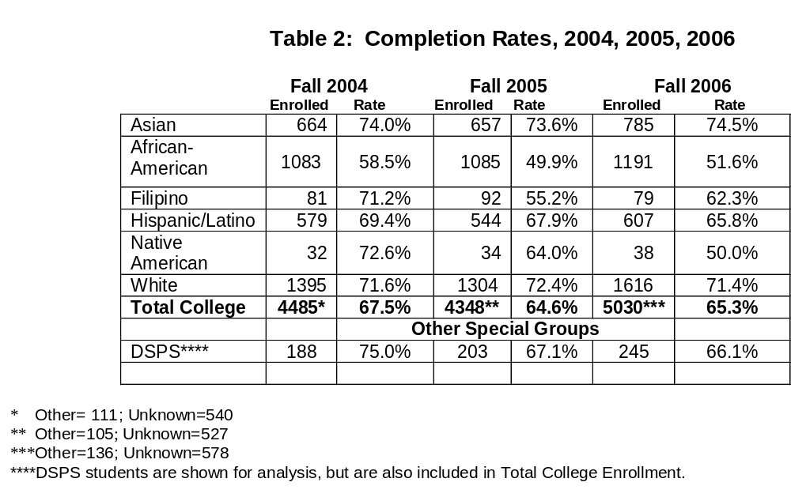

Table 2 shows completion rates for ethnic groups at BCC for fall 2004, fall 2005, and fall 2006, including all courses attempted, comprising basic skill courses and transfer courses. (Completion is considered all students who received A, B, C or Credit. Enrollment does not include students who were enrolled at census date, but dropped the course before the withdrawal date. Thus, enrollment totals in this computation differ slightly from census enrollment.)

In fall 2004, 67.5% of all enrolled students in courses completed them. In fall 2005, the percentage dropped to 64.6%, but an upward direction began in fall 2006 to 65.3%. Of all the ethnic groups included in this report, only African-Americans have completion rates consistently below the college average rates. Moreover, the African-American rate has fallen from 58.5% in fall 2004 to 49.9% in fall 2005 and remains at 51.6% in fall 2006. Native American rates lagged in fall 2006, presenting a rate of 50% as compared to the college average of 65.3%.

C. Basic Skill Completion

Measure: Ratio of the number of students by population group who completed a degree applicable course after having completed the final ESL or basic skills course to the number of those students who completed such a final course.

Multiple views of basic skill success are presented in this section. The Community College Chancellor’s office changed the original metric above (Memorandum October 5, 2004). A broad approach is allowed in this area. Basic skill enrollment numbers are very small at BCC, so that refined analyses are foreclosed since larger numbers of students are required to perform the analyses. However, basic skills education is considered by presenting successful completion rates. All data are drawn from the Peralta mainframe system.

Successes
- Hispanic/Latinos, Asians and whites meet or exceed the college average English basic skill successful completion rates for the years 2004 to 2006.
- Hispanic/Latinos, Asians and whites meet or exceed the college average math basic skill successful completion rates for 2004 to 2006.
Desired Improvements
- Improve the successful completion rate for all groups.
- Increase the information about basic skill completion and lack of completion to design interventions. Further study will allow interventions targeted to specific academic courses, levels and student groups. Additionally, communication about pedagogy for basic skills will raise the level of awareness and increase the inclusion of these students in the community.
- For African-American students, successful completion rates lag in English and math basic skills success by 10%-16% in each year 2004-2006. BCC will improve the completion rate especially for African-Americans as well as other students. Since African-Americans compose half of the basic skills population, attention to basic skills completion will support equity.
- Further data and inquiry are needed about ESL. ESL has been a very small area at BCC, but currently is rapidly growing. Data about the ESL area is currently being developed.
- Completion rates in Basic Skills will be improved overall through the design of an integrated program in Basic Skills, currently under development. New counseling services are planned and new faculty are being hired in this area.

Table 3 shows trends from fall 1999 to fall 2004. The college average rate for basic skills English of 51% is exceeded by groups of Asians at 63.5%, Hispanic/Latinos at 58.3% and whites at 61.3%. A disparity from the average is shown for African-Americans at 44.1%, Filipinos at 30% and Native Americans at 50%. Rates for Filipinos and Native Americans are based on very small numbers, so should be considered less reliable than rates of groups with larger numbers of students.

For mathematics over the years 1999-2004, the college rate of 53% is exceeded by Asians at 66.1%, Filipinos at 60%, Hispanic/Latinos at 63.6%, Native Americans at 60%, and whites at 68.9%. A gap from the average rate is shown for African-Americans at 43.3%.

For both English and mathematics, female students have a higher completion rate for basic skill courses than males. Females in English complete at a 53.2% rate, while males complete at 47.3%. Math completion rates are 53.4% for males and 52% for females.
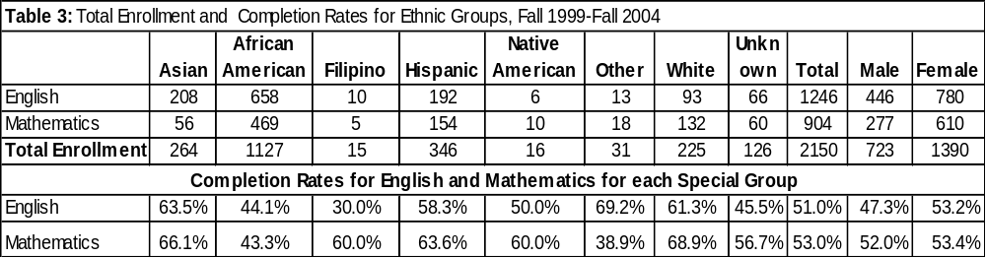
The completion rates for the period 2004, 2005 and 2006 do show ethnic differences (see below, Table 4 and Figures 1,2, 3 and 4). Considering the ethnic composition of Basic Skills, African-Americans are by far the largest group: in 2004, 55.4%; in 2005, 50.6% and 56.9% in 2006. Asians make up 23% in 2004, 21% in 2005 and 22% in 2006, but are found in greater proportions in the English basic skills than in math. Hispanic/Latinos represent a smaller proportion: 14%, 18% and 19%. Whites comprise a still smaller percentage: 10.8%, 10% and 11.4%.

In mathematics from 2004-2006, groups of Asians, Hispanic/Latinos and whites consistently exceed the college rates of 44.1% (2004), 43.6% (2005) and 45.5% (2006). Rates for Filipinos and Native Americans are volatile, since these groups are represented only in very small numbers.

In English basic skills, Asians, Hispanic/Latinos and whites generally exceed the college rates of 44.1% (2004), 55.8% (2005) and 41.1% (2006). The rates for African Americans lag for each year by 1-10%. Rates for Filipinos and Native Americans are volatile, since these groups are represented by very small numbers.

The overall BCC average basic skill completion rate trend shows a possible decline over time; additional long-term data is needed to substantiate any trend. The college averages for the years 1999-2004 are 51% for English and 53% for mathematics, while the college average in fall 2006 is 41.1% English and 45.5% for mathematics. The fall 2006 rates show a drop of 7-10% from the 199-2004 period.

Table 4: Successful Completion Rates and Ethnic Groups, Fall 2004, 2005, 2006

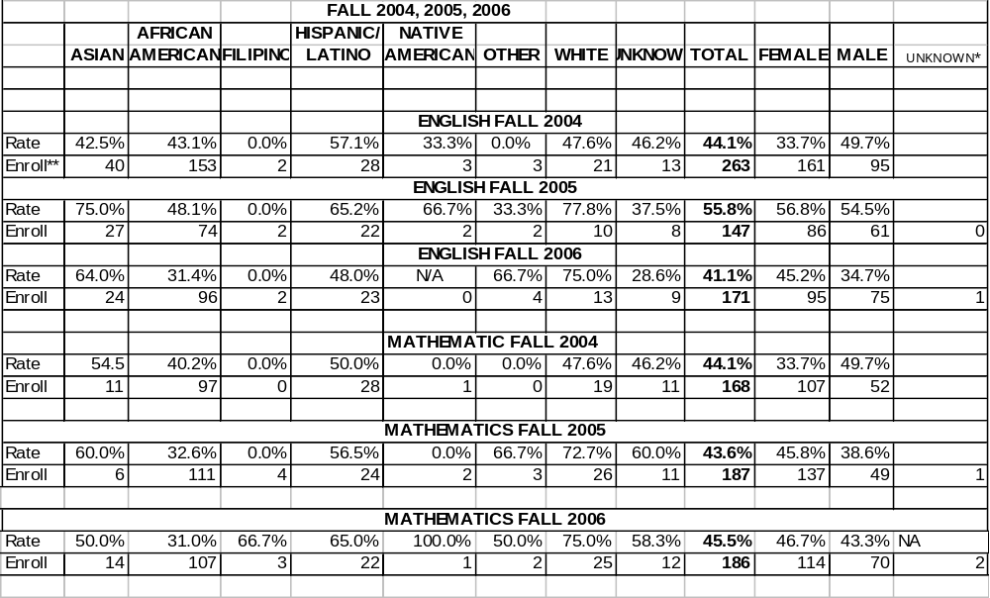
*Unknown gender rates are too small to show validity.
** Shows enrollment in these classes.

Female and Male Success in Basic Skills
A comparison of the genders shows a success advantage for females in math and English relative to males in every year from 2004 to 2006, as shown in Figures 3 and 4. In mathematics, females retain an advantage over males for 2004-2006, although the gap in 2006 narrows to 3% or 46.7% vs. 43.4%.

ESL Successful Completion Rate
Enrolled Rate
ESL Fall 2004 | 184 | 80.4%
Fall 2005 | 379 | 78.1%
Fall 2006 | 664 | 74.4%

Shown above are the rates for ESL students, including basic skills and more advanced courses, comparing very favorably with the overall college rate of 68% (2004), 65% (2005) and 65% (2006). ESL course completion rates are also well above the rates for other basic skills, exceeding these by 25%-35%. The current ESL curriculum is being developed to allow more refined pedagogy and analysis to separate basic skills from advanced course levels.

Figure 1: Successful Completion Basic Skills 2004,2005, 2006*
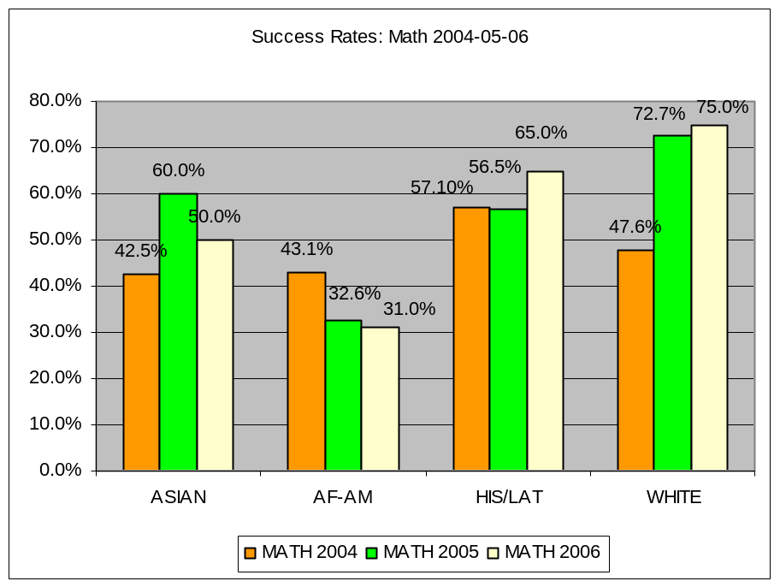

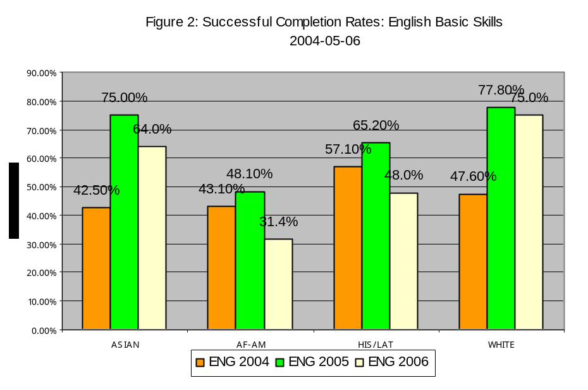

*Ethnic groups with very small student numbers are represented only in Tables, since associated rates are not reliable.

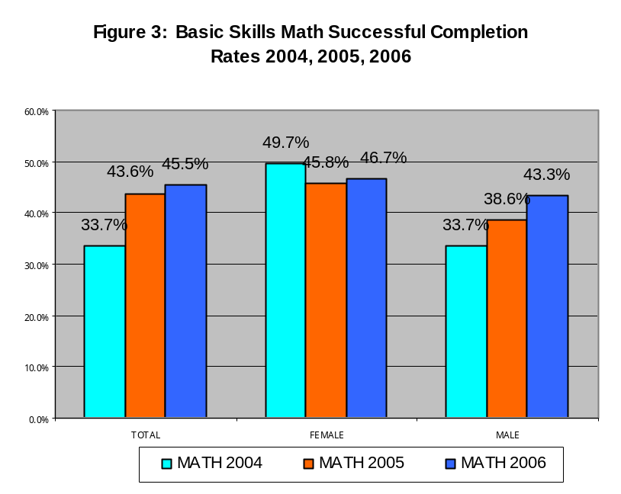

Figure 4

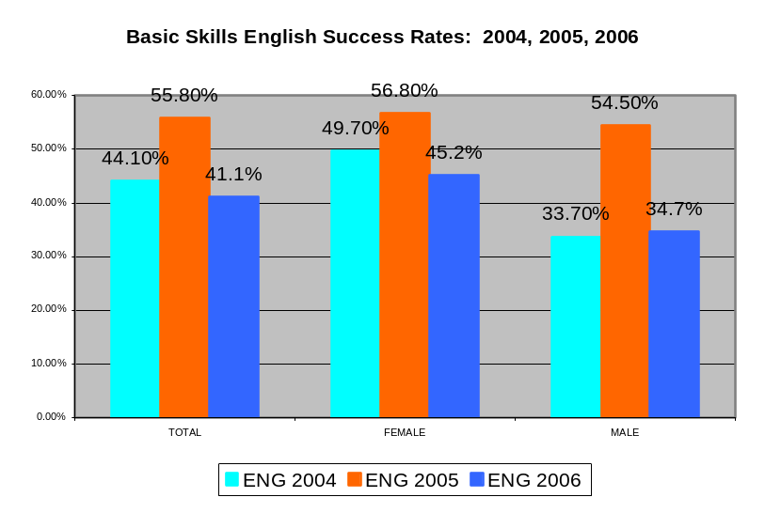

D. Degree and Certificate Completion

Measure: Ratio of number of students by population group who receive a degree or certificate to the number of students in that group with the same informed matriculation goal.

The original ratio measure required by the state Chancellor’s Office was later revised (Memorandum, December 9, 2003 and October 5, 2004), so that the ratio involving the informed matriculation goal is no longer mandated. A broad and descriptive view of degree and certificate completion is used in this report, including several sources of data.
Successes
- African-Americans earned roughly 30% of the AA degrees, 2004-06, while they make up almost 25% of the students.
- Hispanics/Latinos earned 17% of the AA degrees and the same proportion of the certificates, while they represent about 13% of the students.

Desired Improvements
- BCC will improve the numbers of earned degrees, certificates and transfers.
- BCC will continue to develop information about degree and certificate success.
- BCC will design interventions to help students meet their educational and career goals.

Degrees, certificates and ethnicity 2004-06
Degree and certificate rates by ethnicity are considered over time, emphasizing the most recent two years --2004 to 2006 (see Table 5). AA degrees earned by each ethnic group are roughly proportional to the overall group enrollment. It is also recognized that students have diverse goals.

African-Americans tend to earn slightly more AA degrees than their share of the student population. African Americans earned roughly 30% of the AA degrees in 2004-06, while they make up almost 25% of the students. In the period 2001-2004, the percentage of AA degrees earned by African Americans was volatile, ranging from 50% to 26%.

Hispanic/Latinos earn slightly more degrees than their share of the population. Hispanics/Latinos earn 17% of degrees, while they represent 13% of students.

Whites earn slightly fewer degrees than their proportion of the population. White students earned 26% of the AA degrees in 2005-6, while comprising about 33% of the students.

Asians tend to earn slightly fewer AA degrees than their proportion of students.
Asians earn 14% of degrees, while comprising 16.5% of students.

In terms of Certificates of Completion (requires 18 or more units) in 2005-6 (Table 6), white students earned 41% of certificates, greater than their share of the population, and Hispanics/Latinos earned 17%, also more than their share. African-Americans earned 14% of certificates, which is less than their proportion of the population. Asians earned 12%, only slightly fewer than expected from their population share.

Degrees and Certificates by Gender
When degrees and certificates are considered by gender (see Table 6), once again the proportion of AA degrees is consistent with the proportion in the student population. While females represent 60% and males 40%, the proportion of AA degrees awarded show the same proportion--60% to women, while 40% of them go to men. Over the period 2001-2006, the relative proportion of AA degrees awarded to males has shown steady growth.

Overall College Trend
Overall, there is a moderate loss in numbers of degrees and certificates awarded in the most recent two-year period. Such a trend may reflect a growing interest in transfers in the dynamic college student population, as well as growth in students who already hold degrees.

Table 5 : Degrees and Certificates by Ethnicity 2000/01 to 2005/06
AcYr | Deg | Tot | African/  Am |  | Asian/ PI  I |  | Filipino |  | Hisp/ Lat |  | Native |  | Other |  | White |  | Unknown
 |  | # | # | % | # | % | # | % | # | % | # |  | # | % | # | % | # | %
2000-01 | AA | 84 | 42 | 50% | 6 | 7% |  |  | 6 | 7% |  |  | 2 | 2% | 25 | 30% | 3 | 4%
 | AS | 7 | 2 | 29% | 1 | 14% |  |  |  |  |  |  |  |  | 4 | 57%
 | CE | 49 | 9 | 18% | 13 | 27% |  |  | 7 | 14% |  |  |  |  | 19 | 39% | 1 | 2%
 |  | 140 | 53 |  | 20 |  |  |  | 13 |  |  |  | 2 |  | 48 |  | 4
2001-02 | AA | 101 | 40 | 40% | 9 | 9% | 1 | 1% | 17 | 17% |  |  | 1 | 1% | 25 | 25% | 8 | 8%
 | AS | 5 | 1 | 20% | 2 | 40% |  |  | 1 | 20% |  |  |  |  | 1 | 20%
 | CA | 31 |  |  | 15 | 48% |  |  | 5 | 16% |  |  |  |  | 7 | 23% | 4 | 13%
 | CE | 39 | 5 | 13% | 7 | 18% |  |  | 4 | 10% |  |  | 1 | 3% | 15 | 38% | 7 | 18%
 |  | 176 | 46 |  | 33 |  | 1 |  | 27 |  |  |  | 2 |  | 48 |  | 19
2002-03 | AA | 99 | 26 | 26% | 4 | 4% | 3 | 3% | 10 | 10% | 3 | 3% | 4 | 4% | 37 | 37% | 12 | 12%
 | AS | 6 |  |  | 5 | 83% |  |  | 1 | 17%
 | CA | 39 | 3 | 8% | 11 | 28% |  |  |  |  |  |  |  |  | 18 | 46% | 7 | 18%
 | CE | 55 | 9 | 16% | 14 | 25% | 1 | 2% | 5 | 9% |  |  |  |  | 22 | 40% | 4 | 7%
 |  | 199 | 38 |  | 34 |  | 4 |  | 16 |  | 3 |  | 4 |  | 77 |  | 23
2003-04 | AA | 120 | 47 | 39% | 11 | 9% | 3 | 3% | 11 | 9% | 2 | 2% | 4 | 3% | 31 | 26% | 11 | 9%
 | AS | 5 | 2 | 40% |  |  |  |  | 2 | 40% |  |  |  |  | 1 | 20%
 | CA | 52 | 7 | 13% | 11 | 21% |  |  | 15 | 29% |  |  | 1 | 2% | 18 | 35%
 | CE | 61 | 9 | 15% | 14 | 23% | 1 | 2% | 12 | 20% |  |  |  |  | 20 | 33% | 5 | 8%
 |  | 238 | 65 |  | 36 |  | 4 |  | 40 |  | 2 |  | 5 |  | 70 |  | 16
2004-05 | AA | 119 | 36 | 30% | 21 | 18% | 2 | 2% | 14 | 12% | 2 | 2% | 4 | 3% | 25 | 21% | 15 | 13%
 | AS | 2 | 1 | 50% | 1 | 50%
 | CA | 40 | 1 | 3% | 21 | 53% |  |  | 12 | 30% |  |  |  |  | 6 | 15%
 | CE | 55 | 9 | 16% | 21 | 38% |  |  | 5 | 9% |  |  | 3 | 5% | 12 | 22% | 5 | 9%
 |  | 216 | 47 |  | 64 |  | 2 |  | 31 |  | 2 |  | 7 |  | 43 |  | 20
2005-06 | AA | 121 | 39 | 32% | 17 | 14% | 2 | 2% | 20 | 17% | 3 | 2% |  |  | 31 | 26% | 9 | 7%
2005-06 | AS | 2 |  |  | 1 | 50% |  |  | 1 | 50%
2005-06 | CA | 16 | 4 | 25% |  |  |  |  | 3 | 19% |  |  |  |  |  |  | 9 | 56%
2005-06 | CE | 49 | 7 | 14% | 6 | 12% |  |  | 9 | 18% |  |  |  |  | 20 | 41% | 7 | 14%
 |  | 188 | 50 |  | 24 |  | 2 |  | 33 |  | 3 |  |  |  | 51 |  | 25

CE = Certificate of Completion (requires 18 or more units); CA = Certificate of Achievement (requires 6 to less than 18 units)
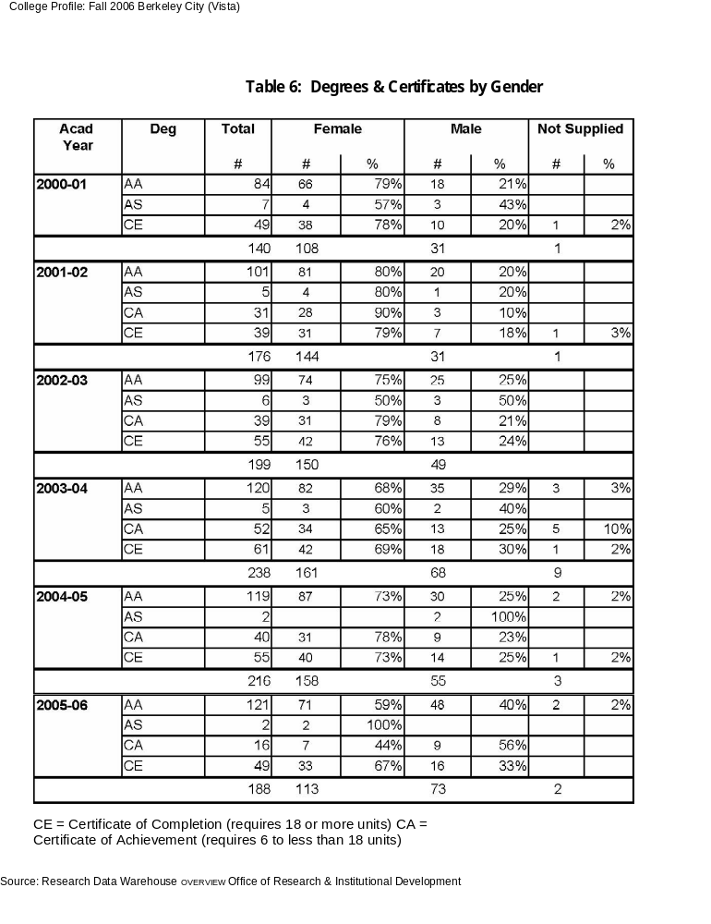
F. Transfer Success

Measure: Ratio of the number of students by population group who complete a minimum of 12 units and have attempted a transfer level course in mathematics or English to the number of students in that group who actually transfer after one or more years (up to six years).

The originally required measure above was modified by Memorandum from the State Chancellor, December 9, 2003, since matching data to determine the transfer rate is not available. The current report takes a broad and constructive approach to reporting about BCC transfers, using information from multiple data sources.

Successes
- BCC shows transfers for all ethnic groups. CSU transfers total 90 (2006/7) and 92 (2005/6). UC transfers total 80 (2006/7) and 82 (2005/6).
- Latinos are second to whites in transfers to UC.
- African-Americans make up a smaller proportion (14%) of the total transfers (2002-07) to the public universities than their proportion in the BCC population (24%). However, the trend in numbers of transfers for African-Americans has been rising.
- National Student Clearinghouse data show that BCC transfers nation-wide (2001 to 2005) numbered 448, comparing very favorably to other colleges.
Desired Improvements
- BCC will increase the numbers of students from all ethnic groups to complete the courses needed to transfer. Special attention will be devoted to improving transfer success for the groups with lowest rates of transfer course completion—African Americans and Hispanic/Latinos, especially males from those groups.
- Transfer numbers show the possibility that growth is stabilizing in themost recent year (2006/07. BCC will attempt to continue transfer growth for all ethnic groups.

Firstly, we report the numbers of transfers from BCC to CSU and to UC by ethnic group. Secondly, we consider transfer readiness of students by ethnicity.

Transfer to UC and CSU
Transfers to UC and CSU-2003-2007
Tables 7 and 8 indicate the number of students who transferred to the University of California system and to the California State University system from BCC, analyzed by ethnicity during the period 2003-2007. (These data are from CPEC--California Post-Secondary Education Commission.)

Total transfers are increasing to both systems. Transfers to the UC system have been increasing rapidly, almost catching up to the numbers of transfers to the CSU system. When transfers are considered by ethnic group for this period, white students transfer in greater number to both systems when compared to each of the other ethnic groups. Whites make up 48% of all transfers to UC (2002-07) with 183 out of 385 total. Latino students are next (57 to UC and 38 to CSU), while Asians trail slightly (41 to UC and 40 to CSU). For the CSU system, African-American students are second to white students in number of transfers. 81 African- Americans from 2003-2007 transferred to CSU, while 117 white students transferred out of a total of 403 for the 2002-07 period.
TRANSFER: Berkeley City College to the University of California and California State University
Table 7: UC Transfers from BCC--- 2002-2007
Year |  | African Amer |  |  | Asian/PI |  |  | Filipino |  | Latino | Native American |  |  |  | Other |  |  |  |  | White |  |  | Non- Res Alien* |  |  |  |  |  | No response |  |  |  |  |  | Total
2003 |  | 2 |  |  | 6 |  |  | 2 |  | 7 | 0 |  |  |  |  | 2 |  |  |  | 27 |  |  | 0 |  |  |  |  |  | 8 |  |  |  |  |  | 54
2004 |  | 4 |  |  | 12 |  |  | 2 |  | 6 | 0 |  |  |  |  | 7 |  |  |  | 34 |  |  | 0 |  |  |  |  |  | 16 |  |  |  |  |  | 81
2005 |  | 7 |  |  | 10 |  |  | 1 |  | 10 | 1 |  |  |  |  | 6 |  |  |  | 45 |  |  | 0 |  |  |  |  |  | 8 |  |  |  |  |  | 88
2006 |  | 8 |  |  | 8 |  |  | 2 |  | 16 | 1 |  |  |  |  | 5 |  |  |  | 37 |  |  | 0 |  |  |  |  |  | 5 |  |  |  |  |  | 82
2007 |  | 7 |  |  | 5 |  |  | 0 |  | 18 | 0 |  |  |  |  | 3 |  |  |  | 40 |  |  | 0 |  |  |  |  |  | 7 |  |  |  |  |  | 80
Total |  | 28 |  |  | 41 |  |  | 7 |  | 57 | 2 |  |  |  |  | 23 |  |  |  | 183 |  |  | 0 |  |  |  |  |  | 44 |  |  |  |  |  | 385
Table 8: CSU Transfers from BCC--- 2002-2007
Year |  | African  Amer |  | Asian |  |  | Filipino |  | Latino |  |  | Native American |  |  |  |  | Other |  |  |  | White |  |  | Non-Res. Alien |  |  | No response |  |  |  |  | Total
2003 |  | 11 |  | 11 |  |  | 1 |  | 5 |  |  | 0 |  |  |  |  | 0 |  |  |  | 24 |  |  | 4 |  |  | 20 |  |  |  |  | 76
2004 |  | 17 |  | 4 |  |  | 1 |  | 4 |  |  | 1 |  |  |  |  | 3 |  |  |  | 19 |  |  | 8 |  |  | 19 |  |  |  |  | 73
2005 |  | 12 |  | 9 |  |  | 3 |  | 10 |  |  | 2 |  |  |  |  | 5 |  |  |  | 20 |  |  | 2 |  |  | 14 |  |  |  |  | 72
2006 |  | 22 |  | 6 |  |  | 0 |  | 10 |  |  | 2 |  |  |  |  | 0 |  |  |  | 28 |  |  | 5 |  |  | 19 |  |  |  |  | 92
2007 |  | 19 |  | 10 |  |  | 2 |  | 9 |  |  | 1 |  |  |  |  | 0 |  |  |  | 26 |  |  | 5 |  |  | 18 |  |  |  |  | 90
Total |  | 81 |  | 40 |  |  | 7 |  | 38 |  |  | 6 |  |  |  |  | 8 |  |  |  | 117 |  |  | 24 |  |  | 90 |  |  |  |  | 403
Source: California Post Secondary Education Commission web site: www.cpec.ca.gov
*Language used in data from CPEC

Transfer-ready rates

In order to evaluate equity issues in the readiness to transfer, a cohort of new students was tracked from the academic years of 2002-2003 through 2004-2005. This timeframe provides a three-year window to become “transfer ready.” Transfer ready students are defined as students attempting and completing both English and mathematics transferable units during the three-year period defined above. As Table 9 shows, the ethnic groups with the highest transfer-ready rates are Asian and white students (both with 15.3%) followed by Hispanic/Latino students (12.2%), Native American (11.1%), Filipino (8.8%) and African-American students (7.5%).

When rates are considered by gender with all ethnicities taken together, male students show a higher rate than females: 13.4% for males and 10.9% for females. DSPS students show a rate of 15.6% as compared to 11.9% without a disability.

Table 9
Cohort of New Students at Berkeley City College Starting in the 2002-2003 Academic Year
and that have completed Transferable Units in English and Math.
 |  |  | .5 TO 11.5 |  | 12 or more units
 | No transferable |  | Transferable |  | At least one English |  | 12 or more units
 | Units completed |  | Units Completed |  | or Math missing |  | English and Math |  | TOTAL
 | Number | % | Number | % | Number | % | Number | %
Ethnicity
Asian | 82 | 27.3% | 106 | 35.3% | 66 | 22.0% | 46 | 15.3% | 300
African American | 132 | 45.1% | 96 | 32.8% | 43 | 14.7% | 22 | 7.5% | 293
Filipino | 10 | 29.4% | 12 | 35.3% | 9 | 26.5% | 3 | 8.8% | 34
Hispanic/Latino | 67 | 37.2% | 58 | 32.2% | 33 | 18.3% | 22 | 12.2% | 180
Native American | 5 | 55.6% | 2 | 22.2% | 1 | 11.1% | 1 | 11.1% | 9
Other | 18 | 46.2% | 3 | 7.7% | 14 | 35.9% | 4 | 10.3% | 39
White | 86 | 21.9% | 153 | 38.9% | 94 | 23.9% | 60 | 15.3% | 393
Unknown | 63 | 33.2% | 62 | 32.6% | 50 | 26.3% | 15 | 7.9% | 190
Gender
Female | 255 | 32.0% | 282 | 35.3% | 174 | 21.8% | 87 | 10.9% | 798
Male | 184 | 31.7% | 190 | 32.8% | 128 | 22.1% | 78 | 13.4% | 580
Unknown | 24 | 40.0% | 20 | 33.3% | 8 | 13.3% | 8 | 13.3% | 60
DSPS
No Disability | 451 | 32.1% | 485 | 34.5% | 302 | 21.5% | 168 | 11.9% | 1406
DSPS | 12 | 37.5% | 7 | 21.9% | 8 | 25.0% | 5 | 15.6% | 32
Total | 463 | 32.2% | 492 | 34.2% | 310 | 21.6% | 173 | 12.0% | 1438

Berkeley City College
Equity Plan, Spring Semester 2007
Goals and Activities

The following are goals and activities that are intended to improve the diversity of students enrolled and working toward degree, certificate, and transfer goals at Berkeley City College. These goals and activities directly relate to key concerns in the areas of Access, Course Completion, Basic Skills Completion, Certificate and Degree Completion, and Transfer which were identified in the BCC Equity Report of fall semester 2006. Finally, the activities are partly in progress and, partly, in development for the spring and fall semesters, 2007.

Access

Student Success Indicator for Access
“Compare the percentage of each population group that is enrolled to the percentage of each group in the adult population within the community served.”

Goal 1. Increase enrollment of diverse ethnic students and disabled students from local high schools, community-based organizations, and other community-based groups.

Activity 1.1: Work with local high schools to develop a clear data base to identify lists of students from local high schools who are good targets for outreach efforts, e.g., students who don’t go to four-year colleges; Exit test non-passers; students who drop out of high school; students whose GPA and our A-G non-completion does not make them eligible for entry into four-year colleges.

Expected outcome 1.1: The result that will occur is that we will identify and contact students who would not have been reached if not for our efforts. Consequently, there will be a more focused interaction between BCC and local high schools, especially with respect to targeted outreach to diverse student groups who require more guidance and support in order to develop and achieve academic and career goals.

Budget 1.1: Will require 30 hrs/week, 11 months Program Specialist Outreach Coordinator ($39,653.00).

Evaluation Schedule and Process 1.1: Set up outreach plan and schedule in Spring 07 and review monthly for progress in fall and spring 07-08. Also, establish baseline data for increasing diversity representation at college and evaluate change in representation at college.

Activity 1.2: Do more intensive outreach/in-reach to local high schools and middle schools via presentations in classrooms, tabling on campus, etc., making sure to establish close communication with teachers and special program coordinators. From this outreach increase the number of diverse high school students who are good targets to encourage and eventually enroll in college programs of study.

Expected Outcome 1.2: Increase the enrollment of diverse populations at BCC, including African-American, Chicano-Latino, and disabled students.

Budget 1.2:: Will require 30 hrs. a week, 11 month Student Services Program Specialist Outreach Coordinator ($39,653.00)

Evaluation Schedule and Process 1.2: Set up outreach plan and schedule in Spring 07 and review monthly for progress in fall and spring 07-08. Also, establish baseline data for increasing diversity representation at college and evaluate change in representation at college.

Activity 1.3: Continue to assist local high schools, especially Berkeley High School, Berkeley Vocational High School, and Emery High School, to do outreach to low-participating parent groups from different ethnic groups.

Expected outcome 1.3: Increase the level of involvement of low-participating ethnically diverse parents in the on-going life of the high school, as well as in the process of supporting their children to continue study into college.

Budget 1.3: Will require 30 hrs./week, 11 month Program Specialist Outreach Coordinator ($39,653.00)

Evaluation Schedule and Process 1.3: Set up outreach plan and schedule in Spring 07 and review monthly for progress in fall and spring 07-08. Also, establish baseline data for increasing diversity representation at college and evaluate change in representation at college.

Activity 1.4: Work with Instructional Outreach Coordinator and Division of Instruction to develop community-based basic skills classes in churches, community-based organizations, and special high school extended learning support programs.

Expected outcomes 1.4: The expected outcome will be an increase in enrollment of diverse student populations at BCC, especially students from groups who normally do not attend college.

Budget 1.4: Will require 30 hrs. a week, 11 month Program Specialist Outreach Coordinator ($39,653.00) and use of existing resources, especially Faculty Community Outreach course developer.

Evaluation Schedule and Process 1.4: Identify specific target populations based on the need for basic skill instruction and develop courses to assist in preparation for either college instruction. Develop two courses per semester commencing in fall 2007. Ensure a minimum enrollment of 25 students.

Budget 1.4: Mathematics instructor to teach two outreach mathematics classes. The estimated budget will be $10,000.

Activity 1.5: Have Ethnic Group Welcome Days for African American, Chicano-Latino, and other low BCC attending ethnic groups where local community individuals and groups, including families, church organization, Community-Based Organizations, etc. are invited to BCC for special welcome-information to college events.

Expected outcomes 1.5: Develop a list of potential students for follow-up calls as well as community contacts who can serve to encourage diverse student populations to attend BCC. Diverse community groups will experience the environment and opportunities available through BCC, which will give more presence in the thoughts and day-to-day experience of community groups who do not normally think about the social, economic and political power that is gained through a college education. Also, the college will have greater contact and involvement with the surrounding community.

Budget 1.5: Will require 30 hrs. a week, 11 month Program Specialist Outreach Coordinator ($39,653.00). This activity will also require partial support of a Student Activities Coordinator on campus, who will organize campus student groups to be thoroughly integrated into this process ($45,000.).

Evaluation Schedule and Process 1.5: Set up schedule in Spring 07 and review following each welcome activity. Also, develop evaluation instrument to glean the impact of the Ethnic Group College Days learning experience on individuals and groups who attend.

Activity 1.6: Work with Programs and Services for Students with Disabilities’ Advisory Board to identify how to better serve this student population.

Expected outcome 1.6: Identify what strategies are most effective to improve the access and success of disabled students, within the scope of resources the college has to devote to support of this student population.

Budget 1.6: No initial budget requirements.

Evaluation Schedule and Process 1.6: From PSSD Advisory Committee recommendations in spring 2007, establish a plan to improve the access of disabled students.

Course Completion

Student Success Indicator for Course Completion
“Ratio of the number of credit courses that students by population group actually complete by the end of the term compared to the number of courses in which students in that group are enrolled on the census day of the term.”

Goal 2: Increase the course completion rate of diverse student populations by initiating specific interventions that promote the completion of courses on the part of students.

Activity 2.1: Increase the number of tutors that work with students across the entire college

Activity 2.1: Develop a cross-college model/framework for tutoring to provide adequate numbers of tutors, including representation of diverse populations, who are trained to provide more powerful, comprehensive diversity-focused college tutoring program.

Expected outcome 2.1: Diverse student groups will have more available and effective tutoring support to complete coursework.

Budget 2.1: Additional tutoring will cost $73.780. This figure is derived from the tutoring priorities identified by the Student Services department head strategic planning group.

Evaluation Schedule and Process 2.1: Set up college-wide tutoring plan, with collaborative development by instruction and student services, and have plan reviewed and accepted by college Leadership Council. Set up college-wide tutoring organization, including criteria for evaluating which target populations and programs will have more intense focus, and then evaluate number of contacts as well as course completion statistics.

Activity 2.2: Establish mathematics and English basic skills student follow-up program wherein faculty, counselors, etc. more closely monitor entrance and movement through basic skill courses.

Expected outcome 2.2: More students will complete more basic skill courses due to effective coordination of instructional and student services and increased monitoring of student progress.

Budget 2.2: One additional counselor added to counseling faculty to focus on coordination of college success initiative with basic skills students. The cost of the position is minimally $49,475., including fringes.

Evaluation Schedule and Process 2.2: Set up program in fall 07, including baseline success rate of current basic skills math and English classes, and evaluate number of contacts and success of students in basic skills math and English classes for subsequent semesters following follow-up intervention program efforts.

Activity 2.3: Develop “buddy-system” in basic skills coursework.

Expected outcome 2.3: More students complete more basic skill courses.

Budget 2.3: One additional counselor added to counseling faculty to focus on coordination of college success initiative with basic skills students, including supporting in the development of the “buddy system” in basic skill classes. The cost of the position is minimally $49,475., including fringes.

Evaluation Schedule and Process 2.3: Set up program in fall 07, including baseline success rate of current basic skills math and English classes, and evaluate number of contacts and success of students in basic skills math and English classes for subsequent semesters following follow-up intervention program efforts.

Activity 2.4: Develop a “buddy system” in special student services programs such as EOPS, CARE, CalWORKs.

Expected outcome 2.4: More students in special student services programs will complete more basic skills coursework.

Budget 2.4: Activity will be folded in to current programs so no additional budget required.

Evaluation Schedule and Process 2.4: Set up program in spring 07, and follow-up on buddy groups during spring 07 and beyond. Determine how effective this system is with respect to supporting the persistence and success of students in all classes, but most especially in basic skill classes.

Activity 2.5: Communicate to faculty and staff, via memorandum and workshops, the results of the fall 2006 Equity Report, including the importance of working more closely with diverse student populations, via the use of innovative teaching and support techniques, to increase the course completion rate of diverse student groups.

Expected outcome 2.5: There will be an increase in the overall understanding and connection to equity concerns on campus by faculty and staff.

Budget 2.5: No additional budget required.

Evaluation Schedule and Process 2.5: Keep track of faculty and staff participation in Equity-related meetings as well as formal communications by faculty and staff regarding equity concerns on campus. Keep semester-by-semester data and include this information in future Equity Reports.

Student Success Indicator for ESL and Basic Skills Completion

“Ratio of the number of students by population group who complete a degree-applicable course after having completed the final ESL or basic skills course to the number of such students who complete such a course.”

Goal 3: Increase the number of students from diverse population groups who complete a degree-applicable course after having completed the final ESL or basic skills course.

Activity 3.1: Develop a data base of students who are taking basic skills and ESL classes, and use this data base as a basis to communicate to this student population as well as to determine the impact of equity-oriented interventions on the success of diverse populations..

Expected outcome 3.1: Data base will allow for differentiation of within and between-group differences with respect to monitoring the success of diverse groups of student vis-à-vis equity goals.

Budget 3.1: One additional counselor added to counseling faculty to focus on coordination of college success initiative with basic skills students. The cost of the position is minimally $49,475., including fringes.

Evaluation Schedule and Process 3.1: Set up program in fall 07, including baseline success rate of current basic skills math and English classes, and evaluate number of student contacts and success of students in basic skills math and English classes for subsequent semesters following follow-up intervention program efforts.

Activity 3.2: Develop a data base of basic skill/ESL students who have completed specific certificate/degrees and share results with Department Chairs and faculty in college Certificate/Degree programs, along with equity goals related to the college’s focus on increasing the success of all diverse student populations in all BCC degree and certificate programs. Identify what works to support diverse students’ success in college Certificate/Degree Programs.

Expected outcome 3.2: Department Chairs and instructors in BCC certificate and degree programs will become aware of college equity goals with respect to completion of degrees and certificate across all student populations. Also, it is expected that college departments will initiate interventions intended to support the success of diverse students in their academic programs.

Budget 3.2: One additional counselor added to counseling faculty to focus on coordination of college success initiative with basic skills students. The cost of the position is minimally $49,475., including fringes.

Evaluation Schedule and Process 3.2: Do yearly communication to faculty and college community regarding the status of equity on campus and monitor the awareness and involvement of the faculty and campus community with respect to specific programs to increase the academic success of diverse student groups on campus.

Activity 3.3: Send letters to and/or do workshops for basic skills students who complete their basic skill coursework, congratulating them on having achieved an important milestone in their college career. In the same letter encourage students toward success in degree/transfer courses. Share with students the importance of the use of different student support services that can assist their success, e.g., Learning Center, Counseling, Programs and Services for Students with Disabilities, etc.

Expected Outcome 3.3 More ESL/Basic Skill students will seek out student support services as they attempt to complete degree/certificate and transfer coursework.

Budget 3.3: One additional counselor added to counseling faculty to focus on coordination of college success initiative with basic skills students. The cost of the position is minimally $49,475., including fringes.

Evaluation Schedule and Process 3.3: Set up program in spring 07 and begin sending letters in summer 07. In subsequent semesters, survey students in all student support programs to see if increased numbers of students seek out services because of letter/workshop following completion of basic skills.

Activity 3.4: Develop a paired developmental math and counseling course sequence, wherein a cohort will be committed for the academic year to improve student retention, persistence, and success in developmental math. The accompanying counseling course would focus on supporting students to understand and better handle math anxiety, improve related study skills, and develop more resilience in the face of challenging math coursework. An important aspect of the counseling course will be that the counselor will develop a one-on-one supportive relationship with students enrolled in the program.

Expected outcome 3.4: More students will successfully complete basic skills mathematics coursework.

Budget 3.4: Incorporate into existing basic skills foundation program in the fall of 07, so no added cost to college.

Evaluation Schedule and Process 3.4: Collect data on student success in math courses, surveying students as to the usefulness of counseling course that accompanies basic skills mathematics course.

Student Success Indicator for Degree and Certificate Completion

“Ratio of the number of students by population group who receive a degree or certificate to the number of students in that group with the same informed matriculation goal.”

Goal 4: Increase the number of students by population group who receive a degree or certificate to the number of students in that group with the same informed matriculation goal.

Activity 4.1: Develop a within and between-groups data base of diverse student populations who are completing certificates and degrees and use this data base in order to better define what populations need to be the focus of increased attention and support with respect to successfully achieving their certificate and degree goals.

Expected Outcome 4.1: Data base will allow for differentiation of within and between-group differences with respect to monitoring the success of diverse groups of student vis-à-vis equity goals in the area of degree and certificate completion as well as to initiate and maintain a support system for student groups who are not achieving their stated and unstated goals in this area.

Budget 4.1: One additional counselor added to counseling faculty to focus on coordination of college success initiative with basic skills students. The cost of the position is minimally $49,475., including fringes.

Evaluation Schedule and Process 4.1: Set up program in fall 07, including baseline success rate of current basic skills math and English classes, and evaluate number of contacts and success of students in basic skills math and English classes for subsequent semesters following follow-up intervention program efforts.

Activity 4.2 Send communication out to all students who have stated their certificate and degree goals informing them of the process involved with achieving their goals as well as the support services available to help them move toward their goals. Do a specific follow-up with African American and Latino students to have students attend a counseling meeting so as to ensure that individuals within these groups receive and follow-up with processes related to achieving goals in the area of certificate and degree completion.

Expected outcome 4.2: There will be more connection and involvement with diverse student populations as they first declare degree and certificate goals, as well as more support for students as they progress toward their stated goals.

Budget 4.2: One additional counselor added to counseling faculty to focus on coordination of college success initiative with basic skills students. The cost of the position is minimally $49,475., including fringes.

Evaluation Schedule and Process 4.2: Set up program in fall 07, including baseline success rate of current basic skills math and English classes, and evaluate number of contacts and success of students in basic skills math and English classes for subsequent semesters following follow-up intervention program efforts.

Activity 4.3 Establish African American and Latino clubs, or work with established clubs, to increase the achievement of certificate and degree goals and the development of leadership within society of these groups.

Expected outcome 4.3: There will be an increased number of African American and Latino students who obtain support for their efforts to achieve degree and certificate goals.

Budget 4.3: Fulltime Student Activities Coordinator to recruit and organize diverse student populations to start and maintain student organizations that focus on support the academic success of all students on campus, but especially student groups that are not succeeding equitably.

Evaluation Schedule and Process 4.3: Set up program in fall 07, and do follow-up survey with students to determine the effect of the communication, including what services they sought out as a result of the communication they received regarding resources available to support achieving certificate and degree goals.

Student Success Indicator for Transfer

“Ratio of the number of students by population group who complete a minimum of 12 units and have attempted a transfer level course in mathematics or English to the number of students in that group who actually transfer after one or more (up to six) years.”

Goal 5: Increase the ratio of the number of African American, Latino, and disabled students who complete a minimum of 12 units and have attempted a transfer level course in mathematics or English to the number of students in that group who actually transfer after one or more (up to six) years.

Activity 5.1: Establish a data based of all student population groups with respect to stated transfer goals, and then establish a program of follow-up with students to ensure that an SEP transfer plan is developed that includes completing basic skill and transfer coursework.

Expected outcome 5.1: Student support services and the department of instruction will be able to identify more clearly what student populations require extra support to achieve success in basic skill and subsequent transfer work.

Budget: One additional full-time counselor added to counseling faculty to focus on coordination of college success initiative in support of students completing basic skill coursework and then successfully moving on and completing transfer level coursework. The cost of the position is minimally $49,475., including fringes.

Evaluation Schedule and Process: This data will be reviewed on a semester-by-semester basis and shared with counselors and special programs on campus, e.g., EOPS, to monitor the on-going success of students as they progress toward their stated transfer goals.

Activity 5.2: Establish a communication system with diverse student populations with respect to informing these groups about the process involved in becoming transfer ready e.g., meeting with counselor and completing Student Education Plans (SEP) for satisfying requirements for transferring to 4-year institutions, as well as learning about the services available to support attainment of transfer goals. Do a specific follow-up with African-American and Latino students, wherein students make appointments to see a transfer counselor.

Outcome 5.2: More of this student population will have counselor contacts and will complete SEP’s.

Budget 5.2: One additional counselor added to counseling faculty to focus on coordination of college success transfer students, including collection of data and dissemination to transfer counselors. The cost of the position is minimally $49,475., including fringes.

Evaluation Schedule and Process 5.2: Set up program in fall 07, including defining baseline numbers of students who declare transfer as their goal. Make it a goal that 100% of these students will complete SEPs with counselors and attend at least one transfer meeting given by local college representatives on campus.

Activity 5.3 Put together a developmental model that shows the process of moving from basic skill coursework to transfer coursework, and, eventually, to successful transfer to a four-year institution. Include in the model cognitive, behavior, and emotional challenges that students have to face and eventually master in order to move through this process, as well as how various college services can support students to successfully transition from basic skill coursework to the level of successfully transferring to a four-year college.

Outcome 5.3: Students will be more aware of what specific cognitive, behavior, and emotional challenges they will face as they enter community college and move through basic skill coursework, transfer coursework, and the process of choosing and preparing to successfully move on to a transfer college.

Budget 5.3: No budget requirement. Use existing staff and planning processes to develop this model.

Evaluation Schedule and Process 5.3: Develop the developmental model in spring 07 and infuse into academic planner and assessment and orientation process for fall 2007.

Activity 5.4: Infuse the developmental model for progression from basic skill coursework through transfer coursework and eventual transfer to a 4-year institution into the college Academic Planner and the Assessment and Orientation process, as well as within all student support services, e.g., Learning Assistance Center; EOPS, etc.

Outcome 5.4: Students who enter and move through the college will be more aware and ready to meet the developmental challenges associated with becoming successful students who transfer to 4-year institutions.

Budget 5.4: No budget requirement. Use existing staff and planning processes to implement this model within on-going student services programs.

Evaluation Schedule and Process 5.4: Infuse developmental model into Academic Planner and Assessment Orientation process in the spring of 2007. Infuse developmental model into student services programs during the 2007-2008 academic year. Also, develop surveys for use with students to evaluate whether or not they find the developmental model to be useful as a guide to successfully navigate the cognitive, behavioral, and emotional challenges of moving from basic skills coursework through to successful completion of transfer to a 4-year college.

For the purpose of this report, basic skills courses in English are English 250, 251 (combined 259), and Mathematics 250, 251 and 253. Transferable Mathematics classes are Mathematics 13, 1, 16A and 16B. Degree Applicable English classes are English 201 A, 201B, 1A and 1B. Thus, only students who completed the final ESL or basic skills courses are taken into consideration when estimating this measure of success.

