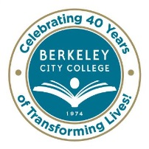
STUDENT EQUITY COMMITTEE
AGENDA
Wednesday, April 15, 2015
9:30 am – 11:30 am
BCC Conference Room 451A/B
Chair: Brenda Johnson

Agenda Review

Approve minutes of 3/18/2015

BCC Scholars

Task Group Updates
Equity Plan Benchmarks and Goals
FELI Training
Learning Resource Center
Other

* * * * * * * * *

~ Student Equity Planning meetings are open to the college community ~

Our Mission: Berkeley City College’s mission is to promote student success, to provide our diverse community with educational opportunities, and to transform lives.

Our Vision: Berkeley City College is a premier, diverse, student-centered learning community, dedicated to academic excellence, collaboration, innovation and transformation.

