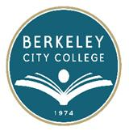
EDUCATION COMMITTEE FOR QUALITY PROGRAMS AND SERVICES

AGENDA
Thursday, August 28, 2014

12:30 pm – 1:30 pm

Room: TLC

- Approve Agenda
- Review and approve meeting minutes
- Committee Norms
- Review Shared Governance Draft for Ed. Committee and Shared Governance Flow Chart
- Ed. Master Plan – Data and timeline

- Committee Updates:
  - Senates
  - PIE Committee
  - Special Projects

