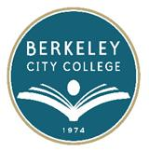
EDUCATION COMMITTEE FOR QUALITY PROGRAMS AND SERVICES

AGENDA
Thursday, April 28th, 2015

12:20 pm – 1:20 pm

Room: 451

Agenda Item
- Call to Order
- Review and approve March meeting minutes 12:15-12:25
- BCC Education Master Plan 12:25-1:00
- Planning process evaluation, focus group discussion (draft form) 1:00-1:20
- Future meeting date 5/12/2016

