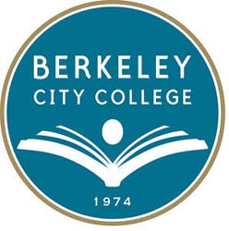
Chairs Council
Date: October 13th 2017 Location: TLC
Chair: Claudia Abadia, Math Dept. Chair (vacant) VPI

Mission: Berkeley City College’s mission is to promote student success, to provide our diverse community with educational opportunities, and to transform lives. The College achieves its mission through instruction, student support and learning resources, which enable its enrolled students to earn associate degrees and certificates, and to attain college competency, careers, transfer, and skills for lifelong success.
Vision: Berkeley City College is a premier, diverse, student-centered learning community, dedicated to academic excellence, collaboration, innovation and transformation.

TIME | AGENDA TOPIC | LEADER | DESIRED OUTCOME
1:30-1:40 | Preview agenda for today’s meeting | Claudia | - Welcome  - Review today’s agenda
1:40-2:10 | Process
 | Guided Pathways Update  - IEPI Conference  - Self Study  PFT/FDIP Announcements | Claudia/Rowena  Scott | - Informational Items
2:10-2:45 | Procedures
 | Faculty Prioritization  Block Schedule  APU Template due 10/31 | Jenny  Claudia | - Planning for 2017-2018
2:45-3:20 | Policies
 |  |  | - Planning for 2017-2018
3:20-3:30 | Wrap up,

Next Meeting
October 27,2017

Members:
Claudia Abadia (Math), Fabian Banga (co-Languages), Mary Clarke-Miller (co-MMART), Barbara Des Rochers (co-Science), Heather Dodge (Library), Iva Ikeda (co-Languages), Thomas Kies (Social Sciences), Cora Leighton (Arts & Cultural Studies), Jenny Lowood (English), Gabriel Martinez (co-Counseling), Siraj Omar (co-Science), Paramsothy Thananjeyan (Business/CIS), Rachel Simpson (co-MMART), Susan Troung (co-Counseling), Gabe Winer (ESL).

