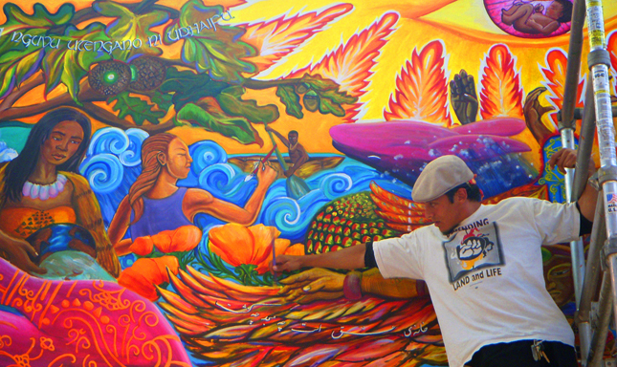

Public Art Certificate of Achievement

Berkeley City College’s Public Art Certificate of Achievement prepares people to participate in local, national and international arenas of public art, through working directly with clients and community as well as in the studio. The True Colors Mural Program at BCC is the cornerstone for the certificate. The program, in collaboration with The Estria Foundation, supports the development of artist activists for the improvement of the urban environment through the creation of public murals. The purpose of the murals is to both educate urban dwellers and beautify the urban environment with messages and images that support ecological sustainability, conservation and restoration. Now with a fully implemented Public Art Certificate Program at BCC, students have a range of course offerings that are both theory and practice- based. You will graduate with skills in the technical areas of mural design and creation, public installation and performance, and public art administration and management. Students will be fully prepared to pursue a professional career at any four year college or university in any of these areas, and to work in the field in community-based organizations upon receipt of their AA degree.

Career Opportunities in
- local, national and international arenas of public art, for which working with clients and community are a critical part.
- technical skills for mural design and creation, public installation and performance, and public art administration and management

Required Courses | Units | Semester | Semester
 |  | Offered | Completed
ART 020 Beginning Drawing & Composition | 2-3 | All
ART 050 Beginning Painting | 2-3 | All
ART 133A Mural Design and Creation I | 3 | Fall
ART 133B Mural Design and Creation II | 4 | Spring
ART 181 Artist as Citizen: Community-Based Art Practices | 3 | Spring
Required Art History Courses (choose one of the following)
ART 001 Introduction to Art History | 3 | All
ART 004 History of Modern Art (1800 to Present) | 3 | All
ART 013 History of Women in Art (19th & 20th Centuries) | 3 | Fall
ART 014 Themes, Trends, and Traditions in World Art | 3
ART 016 Introduction to Islamic Art *Online | 3 | Spring
ART 182 Introduction to Visual Culture | 3 | All
HUMAN 182 Introduction to Visual Culture | 3
Studio Art Electives (choose 2-3 units of the following)
ART 018 Critique and the Creative Process | 3 | Spring
ART 044 Three Dimensional Design | 3 | Fall
ART 175 Studio Art Laboratory | 1
ART 180 Introduction to Conceptual Art | 3
MMART 196A Art Marketing and Portfolio Management 2 | 2
MMART 196LA Art Marketing and Portfolio Management LAB 1 | 1
Possible Substitutions
Ecoart matters: art 141-li

Total Units for Certificate | 19-22

Counselor Signature

Art Faculty Signature

